EX No:1A | SETTING UP PYTHON ENVIRONMENT AND  LIBRARIES – JUPYTER NOTEBOOK

Aim:

To install Python, configure Jupyter Notebook, understand the notebook environment, execute Python programs, create Markdown cells, and use basic Jupyter Notebook features for Data Analytics applications.

Algorithm:

Algorithm 1: Installing Python
- Download Python from python.org
- Run the installer
- Select "Add Python to PATH"
- Click Install Now
- Verify installation using: python --version
- Observe installed Python version

Algorithm 2: Installing Jupyter Notebook
- Open Command Prompt
- Install Jupyter pip install notebook
- Launch Jupyter Notebook jupyter notebook
- Browser automatically opens Notebook Dashboard.

Algorithm 3: Creating a Notebook
- Open Jupyter Dashboard
- Select New → Python 3
- Create Notebook
- Rename Notebook
- Create Code and Markdown Cells
- Execute cells using Shift + Enter
Program:
Program 1 — Simple Python Program print("Welcome to Data Analytics Lab") Output:
Welcome to Data Analytics Lab

Program 2 — Arithmetic Operations a = 20 b = 10 print("Addition =", a + b) print("Subtraction =", a - b) print("Multiplication =", a * b) print("Division =", a / b)
Output:
Addition = 30
Subtraction = 10
Multiplication = 200
Division = 2.0

Program 3 — Display Student Details name = "John" dept = "AI&DS" cgpa = 8.9 print("Name:", name) print("Department:", dept) print("CGPA:", cgpa)
Output:
Name: John
Department: AI&DS CGPA: 8.9

Program 4 — Creating Markdown Cell
# Data Analytics Lab
## Experiment 1
### Jupyter Notebook
Then press Shift + Enter.

Program 5 — Using NumPy Library import numpy as np a = np.array([10, 20, 30, 40, 50]) print(a) print("Mean =", np.mean(a)) print("Sum =", np.sum(a))
Output:
[10 20 30 40 50]
Mean = 30.0
Sum = 150

Program 6 — Using Pandas Library import pandas as pd data = {
'Name': ['John', 'David', 'Alex'],
'Marks': [85, 90, 95]
} df = pd.DataFrame(data) print(df)
Output:
Name Marks

- John 85
- David 90
- Alex 95
Program 7 — Data Visualization import matplotlib.pyplot as plt x = [1, 2, 3, 4, 5] y = [10, 20, 15, 25, 30] plt.plot(x, y) plt.title("Sample Line Graph") plt.xlabel("X Axis") plt.ylabel("Y Axis") plt.show()
Output:

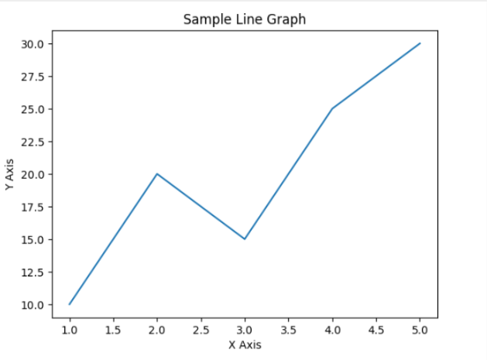

Result:

EXPT NO:1B | OCEAN PLASTIC POLLUTION - MACHINE LEARNING

AIM:
To clean and preprocess the Ocean Plastic Pollution dataset by detecting and handling missing values, merging related datasets, removing duplicate records, checking data types, and normalizing numerical data using Min-Max Scaling and Standardization.

PROCEDURE:
1. Load the Ocean Plastic Pollution and Mismanaged Plastic Waste CSV datasets using Pandas.
2. Detect missing values using isnull().sum().
3. Merge the ocean pollution and mismanaged plastic waste datasets using Entity, Code, and Year.
4. Fill missing values in the Code column with "Unknown".
5. Detect and remove duplicate records.
6. Check the data types of all columns.
7. Select relevant numerical columns for normalization.
8. Apply Min-Max Scaling to the selected numerical columns.
9. Apply Standardization using StandardScaler.
10. Display the cleaned and normalized data.
11. Display the final dataset information.
CODE:
import pandas as pd
import matplotlib.pyplot as plt

# Load the Ocean Pollution dataset
df = pd.read_csv("Ocean_Pollution_Dataset.csv")

# -------------------------------
# 1. DATA UNDERSTANDING
# -------------------------------

print("Dataset Shape:")
print(df.shape)

print("\nColumn Names:")
print(df.columns)

print("\nFirst 5 Records:")
print(df.head())

print("\nDataset Information:")
print(df.info())

print("\nStatistical Summary:")
print(df.describe())

# -------------------------------
# 2. DATA EXPLORATION
# -------------------------------

print("\nMissing Values:")
print(df.isnull().sum())

print("\nOcean-wise Pollution Index:")
print(df.groupby("Ocean")["Water_Pollution_Index"].mean())

# -------------------------------
# 3. DATA VISUALIZATION
# -------------------------------

# Year-wise plastic waste
yearly_pollution = df.groupby("Year")["Plastic_Waste_Tonnes"].mean()

plt.figure(figsize=(8, 5))
plt.plot(yearly_pollution.index,
yearly_pollution.values,
marker="o")

plt.title("Average Plastic Waste by Year")
plt.xlabel("Year")
plt.ylabel("Plastic Waste (Tonnes)")
plt.grid(True)
plt.show()

# Ocean-wise pollution
ocean_pollution = df.groupby("Ocean")["Water_Pollution_Index"].mean()

plt.figure(figsize=(8, 5))
plt.bar(ocean_pollution.index,
ocean_pollution.values)

plt.title("Average Water Pollution Index by Ocean")
plt.xlabel("Ocean")
plt.ylabel("Pollution Index")
plt.xticks(rotation=25)
plt.show()

# -------------------------------
# 4. CORRELATION ANALYSIS
# -------------------------------

numeric_data = df.select_dtypes(include="number")

correlation = numeric_data.corr()

print("\nCorrelation Matrix:")
print(correlation.round(2))

# -------------------------------
# 5. KDD / SEMMA / CRISP-DM
# -------------------------------

print("\nCRISP-DM:")
print("Business Understanding")
print("Data Understanding")
print("Data Preparation")
print("Modeling")
print("Evaluation")
print("Deployment")

print("\nSEMMA:")
print("Sample")
print("Explore")
print("Modify")
print("Model")
print("Assess")

print("\nKDD:")
print("Selection")
print("Pre-processing")
print("Transformation")
print("Data Mining")
print("Interpretation and Evaluation")

Dataset Shape:
(50, 10)
Column Names:
Index(['Year', 'Ocean', 'Country', 'Plastic_Waste_Tonnes', 'Oil_Spill_Tonnes',
'Marine_Debris_Tonnes', 'Water_Pollution_Index',
'Microplastic_Level_mg_L', 'Affected_Marine_Species',
'Cleanup_Cost_USD'],
dtype='object')

First 5 Records:
Year Ocean Country Plastic_Waste_Tonnes Oil_Spill_Tonnes \
0 2015 Pacific Philippines 33795 1260
1 2015 Atlantic South Africa 62131 3319
2 2015 Indian China 80955 2833
3 2015 Arctic China 77150 589
4 2015 Southern India 49551 1928

Marine_Debris_Tonnes Water_Pollution_Index Microplastic_Level_mg_L \
0 47158 58.49 1.51
1 25023 62.26 1.62
2 14311 69.54 1.89
3 28118 69.29 1.68
4 20394 59.82 1.63

Affected_Marine_Species Cleanup_Cost_USD
0 104 19050
1 104 28579
2 93 30317
3 109 25154
4 102 20845

Dataset Information:
<class 'pandas.core.frame.DataFrame'>
RangeIndex: 50 entries, 0 to 49
Data columns (total 10 columns):
# Column Non-Null Count Dtype
--- ------ -------------- -----
0 Year 50 non-null int64
1 Ocean 50 non-null object
2 Country 50 non-null object
3 Plastic_Waste_Tonnes 50 non-null int64
4 Oil_Spill_Tonnes 50 non-null int64
5 Marine_Debris_Tonnes 50 non-null int64
6 Water_Pollution_Index 50 non-null float64
7 Microplastic_Level_mg_L 50 non-null float64
8 Affected_Marine_Species 50 non-null int64
9 Cleanup_Cost_USD 50 non-null int64
dtypes: float64(2), int64(6), object(2)
memory usage: 4.0+ KB
None

Statistical Summary:
Year Plastic_Waste_Tonnes Oil_Spill_Tonnes \
count 50.000000 50.000000 50.000000
mean 2019.500000 56279.960000 2593.280000
std 2.901442 21005.487118 1176.966666
min 2015.000000 18206.000000 516.000000
25% 2017.000000 38298.750000 1715.750000
50% 2019.500000 59887.500000 2878.500000
75% 2022.000000 72572.250000 3502.750000
max 2024.000000 89295.000000 4497.000000

Marine_Debris_Tonnes Water_Pollution_Index Microplastic_Level_mg_L \
count 50.000000 50.000000 50.000000
mean 29782.820000 61.625000 1.609000
std 11938.321122 8.928284 0.315823
min 10679.000000 38.890000 0.920000
25% 19785.500000 56.820000 1.412500
50% 30450.500000 62.270000 1.640000
75% 38126.250000 68.410000 1.827500
max 48976.000000 83.610000 2.110000

Affected_Marine_Species Cleanup_Cost_USD
count 50.000000 50.000000
mean 104.160000 25798.140000
std 12.357531 6516.797423
min 76.000000 11004.000000
25% 95.250000 20037.750000
50% 104.000000 25329.000000
75% 113.000000 30894.250000
max 127.000000 40619.000000

Missing Values:
Year 0
Ocean 0
Country 0
Plastic_Waste_Tonnes 0
Oil_Spill_Tonnes 0
Marine_Debris_Tonnes 0
Water_Pollution_Index 0
Microplastic_Level_mg_L 0
Affected_Marine_Species 0
Cleanup_Cost_USD 0
dtype: int64

Ocean-wise Pollution Index:
Ocean
Arctic 56.978
Atlantic 62.409
Indian 64.673
Pacific 62.745
Southern 61.320
Name: Water_Pollution_Index, dtype: float64
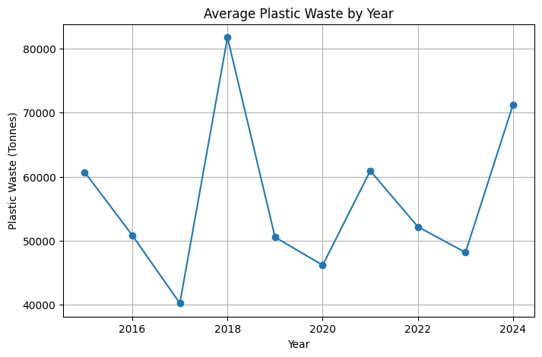
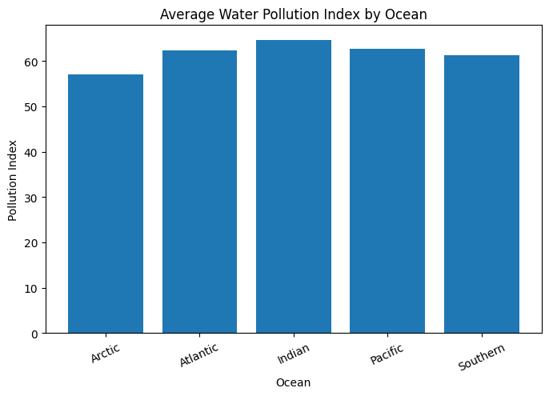Result:

